THE SUBTITLE STRATEGY OF SLANG TRANSLATION IN “21 JUMP STREET” MOVIE’S FAN SUBTITLES

Mar’i Muhammad Bima Saputra
bimasaputrasn@gmail.com
Teleperformance Indonesia

Abstract
Slang is one of variations in speech that requires experience and knowledge. Some slang is used to identify the speaker as well as communicating messages. Slang also appears in the subtitles of the film. Related to this case, this research aims (1) to describe types of slang that is found in 21 Jump Street movie produced by Metro-Goldwyn-Mayer and Original Film, (2) to describe what subtitle strategies that the subtitler used to translate the slang in 21 Jump Street movie produced by Metro-Goldwyn-Mayer and Original Film, and (3) to describe the relationship between the most widely used subtitling strategies and the type of slang that dominantly appears in 21 Jump Street movie produced by Metro-Goldwyn-Mayer and Original Film. This research is descriptive qualitative research and the expert is involved in the case to validate the data analysis. The author submitted the results of the data found in the form of slang in 21 Jump Street to the validator, who will then check and revise the types, types and explanations in each slang. The writer analyzed the data once the results have been validated, and found 145 final data. From the research results, 21 data are categorized as "Group- and subject-restriction", 2 data as "Secrecy and Privacy", 67 data as "Informality and Debasement", and 55 data as "Vulgarity and Obscenity." The most common category is the "Informality and Debasement" category. On the second analysis, of these 145 data, the strategy mostly used by the subtitler or translator is the "paraphrasing" strategy with a total of 57 data. The type of slang that is mostly found which is "Informality and Debasement" is most dominantly translated using the "paraphrasing" strategy. This suggests that slang representing intimacy and informality cannot be translated into the same form and way as the source language. The informality here can mean that the characters in this film see the people around them as close people or even to make strangers closer. The strategy used also influences the meaning contained. Because the translation using the "Informality and Debasement" strategy does not translate the original form of slang in the source language, but changes it back into something more flexible and accepted by the audience. If the slang is translated according to the rules, then the meaning and expressions contained will not be conveyed successfully.
Keywords: Subtitling Strategies, Slang, Translation, Fan Subtitles, 21 Jump Street

INTRODUCTION
Slang is one of the seasonal variations of language. It is spoken only by certain circles. Young people have their own slang, and so do their parents. Slang is often spoken not according to its original meaning. That is why it is necessary to have knowledge of the background, the situation of the conversation and who the speaker is. The meaning of slang itself often changes with the development of generations. Some slang is no longer used nowadays, and vice versa. A lot of new slang has emerged but old people may not understand it. Slang is defined into two main meanings; (1) slang is a time-restricted ephemeral phenomenon and (2) slang has a rather wide, all-encompassing nature (Mattiello, 2005). The first means that slang is considered as terms that exist only for some time. The slang “Gordon Bennett!” which means an exclamation for anger or surprise only existed in 1850 until 1880. The second means that slang has wider meanings within its concept due to a terminological merging. Rather than a single accurate meaning, the concept of slang is created according to non-standard language varieties.
Slang is used in everyday conversation including ones that appear in the movie and it is made clearer with the movie’s subtitle. Subtitle itself is a short text that contains the transcript or translation from utterances that are spoken by characters in a film or any other audiovisual works. The term "fansub" refers to subtitles created by fans for television shows that they enjoy (Rong, 2018). Fansub is different from the official subtitles which go within the films in the cinema or DVD. Fansub is an option for those who want to watch movies with a different style. Usually, fansub does not follow the rules or regulations that apply in the official subtitles. Therefore, with the difference between fansub and official subtitles, it gives freedom in translating or making subtitles for subtitler fans. Fansub can be obtained for free by downloading it on a website. One of the biggest fansub providers is Subscene (https://subscene.com/). Subscene is a site where people can search, download or upload fansub for a film. Here, Subscene provides a variety of fansub from films all over the world in various languages. Similar to a forum, Subscene also provides features to create special accounts to be able to do various things on the site, such as uploading, rating, commenting and even discussing subtitles with other accounts. An uploaded fansub usually has a rating from various accounts there to indicate whether it is a good fansub or not. In addition, the fansub researched at this time is devoted to subtitles which focus on describing slang where there are 2 versions in it, namely the original version and the slang version (EricKorfeZ_17, 2014).
The translation of language variations, especially slang, requires the right subtitle strategy so that the meaning and expression of the speaker can be conveyed properly. This statement is also reinforced by the results of research from an article that examines translation strategies aimed at "pun" revealing that the use of certain strategies has an impact on the delivery of meaning and the humor conveyed (Natarina, 2012). Using Henrik Gottlieb's theory as stated by (Ghaemi & Benyamin, 2011) for subtitling strategies, the writer wants to analyze how the subtitler applied certain strategies to translate the slang. Gottlieb stated that there are ten strategies to translate in the subtitles. There are expansion, paraphrasing, transfer, transcription, dislocation, condensation, decimation, deletion, and resignation.
Slang is spoken in many western movies, for example, 21 Jump Street. It is an adaption movie from the serial that is taken the same title that aired in 1987. 21 Jump Street is directed by Phil Lord and Christopher Miller. The movie is released theatrically on March 16, 2012, by Colombia Picture and Metro-Goldwyn-Mayer. Slang is known for its meaning. The movie took the story in the teenagers' lives since slang is mainly spoken by them in society. The slang also focused on crime and high school so the slang is commonly found throughout the movies. In 2012, the year 21 Jump Street aired, many films based on novels or previous works were remade. The writer can’t translate the slang literally. It has a specific meaning that distinguishes it from other varieties of language. The subtitler in this movie, uses certain subtitles strategy to translate the slang into the target language.
An example from the data obtained for this study from the film "21 Jump Street" is to provide a better understanding of how to translate slang in the subtitle.
Figure 1. Example of Slang
Source Sub | Target Sub
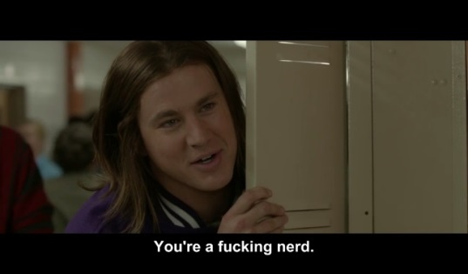 | 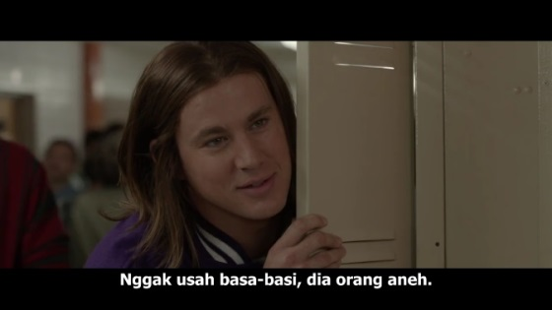

From figure 1, one of the main characters degrades the other main character by calling him “fucking nerd”. Schmidt, the one that is called for “fucking nerd”, is asking one of his female friends to go to the prom with him in that scene. Therefore, the woman rejected it. Jenko, the one that calls Schmidt “fucking nerd”, seen in that episode immediately degrades him by calling that name.
Here, the slang fucking nerd according to theory that is used by the writer is categorized as the slang of vulgarity and obscenity. This slang is supposed to degrade someone by using vulgar or curse words. Nerd is slang for a person that is considered to be socially awkward, boring, or unstylish. This term is also dominantly mentioned for computer or technology enthusiasts. Then, the subtitler translates this slang into the word orang aneh which means a weird guy. This term is not even slang in Indonesia but it is a simplified word. As seen in Figure 1, the slang speaker is a young student, which indicates that slang is a special slang for young people. The subtitler here uses paraphrasing strategy to translate the slang. He paraphrases the slang nerd as orang aneh which is not even categorized as slang in Indonesia but the word still has a similar meaning. Paraphrasing is used in the translation to describe or convey the meaning contained in the slang without giving the same expression. Swear words were also removed to focus on translating slang into common languages.
The researcher chose 21 Jump Street as the object of the research is because the movie took the story in the teenagers' lives since slang is mainly spoken by them in society. The slang also focused on crime and high school so the slang is commonly found throughout the movie. In 2012, the year 21 Jump Street aired, many films based on novels or previous works were remade. There are even sequels made. 2012 was one of the golden years of Hollywood cinema (Wood, 2013).
RESEARCH METHOD
This paper is descriptive qualitative research because the author uses several methods to sort, analyze and describe the data found. Qualitative research is one of the approaches that aims to find the quality of the problem or the situation (Fraenkel et al., 2011). The researcher tries to achieve the goal of providing an explanation of the problem that they have discovered. This research focuses on describing the subtitle strategies used by subtitlers in making and translating subtitles. It also explains the reasons why subtitlers translate subtitles using certain strategies. Thus, this research can be used as an evidence or additional research of slang translation strategy to strengthen other theories.
The author wants to analyze the slang translation strategy that is used by the subtitler in 21 Jump Street movie subtitles. In order to do that, the research acquires all the data by watching the movie, putting the subtitle file of 21 Jump Street into the movie and collecting the data from that subtitle. The data of this research are classified as slang which is one of the language varieties. From the collected data, the researcher also wants to describe that the data are collected from English and Indonesian subtitles of 21 Jump Street movie. The subtitles are downloaded from http://www.subscene.com. The source of the data was also collected from the movie scene of 21 Jump Street in order to know the context of the slang. Then, the data that have been collected and classified are submitted to the validator to be validated whether the data fit the theory or not.
Data analysis is the researcher's way to examine all data obtained when collecting data in various ways and to use certain theories to find an outcome. With a variety of specific steps, the researcher conveys the analysis of data in detail in order to achieve the desired conclusions. This research is categorized as qualitative research in which this study includes analyzing data and uses descriptive methods.
FINDINGS AND DISCUSSION
In this section, the researcher would describe the research finding that has been fitted the theory before. This research covers an analysis that contains the main characters’ slang from “21 Jump Street” movie. The researcher found 145 data. From the first problem statement, there are 21 data that are categorized as "Group-and subject-restriction", 2 data as "Secrecy and Privacy", 67 data as "Informality and Debasement", and 55 data as "Vulgarity and Obscenity". The most common category is the "Informality and Debasement"
Type of Slang Presented in “21 Jump Street” Movie
Group-and subject-restriction
Group-and subject-restriction is a slang that is formed to become an identity for a particular group which presupposes similar conversation topics and related areas for discussion. Each speaker here shares the same interests, concerns, values, activities and habits in order to have the same topic of conversation and deliver the slang easily.
Figure 2. Example of Slang in 21 Jump Street: Perp
SL | TL
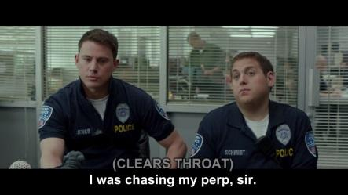 | 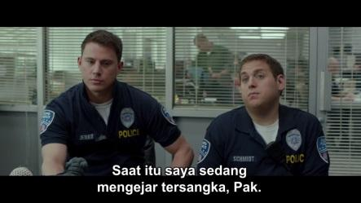
I was chasing my perp, sir. | Saat itu saya sedang mengejar tersangka, Pak.

The slang is spoken by the character at 0:10:05.81 – 0:10:09.11 in the movie. In this scene, Schmidt and Jenko finally returned to their base without any success after they had chased the suspects in the park in the previous scene. At his headquarters, in the office of their deputy chief, Schimdt and Jenko reported the incident while showing the injuries they had received. At that time, the deputy chief asked Schmidt where he was when it.
Urban Dictionary defines the slang “perp” with the following explanation: an abbreviation for perpetrator (someone suspected of a crime) (50-Septim, 2005). From this definition, the researcher concludes that the slang “perp” is a slang used to denote the chased suspect in the police language. The reason why this slang is included in that category is because it is dominantly used by the police to indicate their suspect. Also, this category has a purpose to indicate who the speaker is by knowing what slang is spoken. Thus, in conclusion, the slang “perp” is categorized into group-and subject- restriction because it is a police language and has a purpose to indicate the police’s suspect.
Secrecy and Privacy
Secrecy and privacy are a slang that aims to convey information confidentially and dominantly. It is used for a certain group, especially criminals. In this category, slang is intended so that the information conveyed by the speaker is kept confidential. Many people use this slang to talk about illegal things such as drugs, prostitution, theft, and others. Because of its purpose, this slang does not appear that much in film like others.
Figure 3. Example of Slang in 21 Jump Street: “Pop”
SL | TL
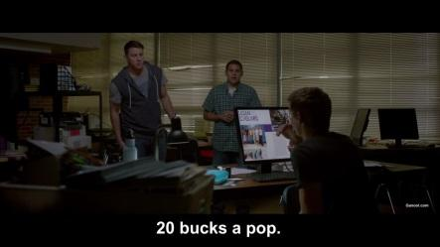 | 
One each? One pop each of drugs. | Masing-masing sebungkus aja.
The slang appears at 0:32:01.42 – 0:32:04.38. At this scene, after Schmidt and Jenko found out the drug dealer, they planned to buy the drug and take it to their captain. They bought one for each. They said “One pop each of drugs” to indicate it. According to Urban Dictionary, the slang “A pop” is a drug dealing talk referring to how much the seller is charging for each pill (4apopper, 2010). This means that this slang is used to cover or hide a certain term, in this case drug, which is known only by the perpetrators. Therefore, the researcher categorized it into “secrecy and privacy” type of slang. The slang “pop” obviously indicates that this term is confidential to common people. It’s the reason why the researcher categorizes it into “secrecy and privacy”.
Informality and debasement
Informality and debasement is a slang used to express intimacy to eliminate formalities in a conversation. This slang is usually used by people who are already close or just to break the formalities.
Figure 4. Example of Slang in 21 Jump Street: “Chill”
SL | TL
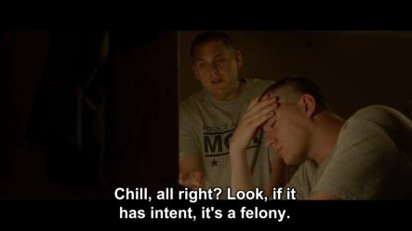 | 
Chill, all if it has intent, it's a felony.right? Look, | Santai sih, liat !
This slang appears at 0:04:18.88 – 0:04:22.30. Schmidt and Jenko finally became friends at the police academy after previously fighting each other in high school. They make friends to help each other in completing their academy. Schmidt helps Jenko academically, while Jenko helps Schmidt physically. At this scene, Jenko had a hard time learning about police academics. Schmidt, who has an edge in that area, helps Jenko calmly. Schmidt said “Chill, all if it has intent, it's a felony.right? Look”. Here, the word “chill” can be counted as slang.
According to Urban Dictionary, the slang “chill” can be explained by: to calm down, to hang out, and to be easy going or a little bit cold (W., 2005). In accordance with the context of the story in the scene, the slang "chill" means to remain calm in facing something. The slang is categorized into “informality and debasement” category. They use the slang to indicate that they are close enough to make that kind of dialogue. The slang is dominantly used by two people who already know each other or even used by two people who are closely related. It can also be used to break up the current situation. In this case Jenko was angry because he couldn't make a decision on the academic question. Shcmidt finally told him to stay calm by using slang. In short, the slang is categorized into “informality and debasement” since its origin and purpose.
Vulgarity and Obscenity
Vulgarity and obscenity is a slang used for the purpose of cursing or expressing anger at someone. The slang has the intent to degrade the listener by using swear words.
Figure 5. Example of Slang in 21 Jump Street: “Fuck you”
SL | TL
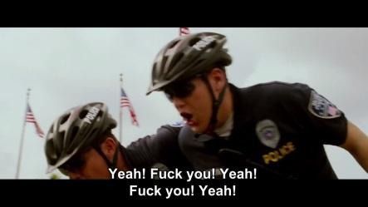 | 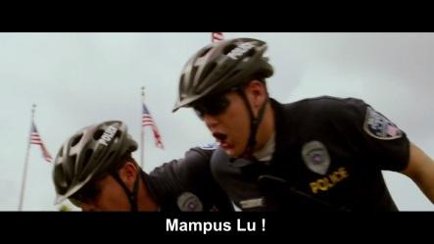
Yeah! Fuck you! Yeah! Fuck you! Yeah! | Mampus Lu !

This slang appears at 0:08:38.60 – 0:08:40.89. In this scene, Schmidt and Jenko found a case during their first assignment at the park. There, they met a criminal group called "One Percenters". After various unpleasant conversations, they found an item that was very suspicious. After that, the group finally ran away from Shcmidt and Jenko. One of the members of "One Precenters" who is the leader of the group was finally caught by Jenko. After they arrest him, then they cursed him with “Fuck you!”.
According to Urban Dictionary, the slang “fuck you” is a term used to say you strongly hate or dislike someone. It can be used to say to someone who is upset with, or someone who is hated (Kailey12345, 2010). Therefore, this word is dominantly used to insult someone who is very hated. In this case, Jenko and Schmidt cursed the member of the criminal group with angry tones. Therefore, judging from the slang and the situation in which it is pronounced, this word is categorized as "vulgarity and obscenity".
Subtitling Strategies Presented in “21 Jump Street”
The research was carried out by comparing the official subtitles with the fan subtitles made by EricKorfeZ_17 in Subscene. The subtitles used as data are obtained from one of the largest websites related to subtitle fans. The subtitles that the researcher uses to compare with the original subtitles have been rated well by people in the Subscene community. This research focuses on fan subtitles because the subtitles created by the user are special slang subtitles as written in the subtitle description. Here, the researcher would compare the slang found in the movie "21 Jump Street" with the fan subtitles. Then these comparisons would be categorized into several subtitling strategies by Gottlieb.
The results are as follows; 6 slang on Expansion, 55 slang on Paraphrasing, 38 slang on Transfer, 12 slang on Condensation, 14 slang on Decimation, 11 slang on Deletion and 9 slang on Resignation. In conclusion, this movie mostly contains the slang on Paraphrasing with 55 slangs in total.
In conclusion, the most dominant strategy in translating or making subtitles is paraphrasing. Through this strategy, the slang contained in the source language is translated in different forms because some slang cannot be translated equally into the same form and format as the source language. This condition happens to avoid the lack of meaning and different expression in the target language. Some slang is also rarely heard or do not have equivalent words in the target language, therefore some slang is translated using a paraphrasing strategy.
“Informality and Debasement” is the type of slang that is mostly spoken in the film by the main character. Informality and debasement is a slang used to express intimacy to eliminate formalities in a conversation. This slang is usually used by people who are already close or just to break the formalities. This type is dominantly pronounced in movies. This is because this film contains a lot of things about friendship and informality. Most of the characters in this movie are teenagers since it was taken place in high school. On the other hand, this movie tells about how teenagers do their activities inside and outside the school environment. Studying, hanging out, socializing, partying, drug taking and dating are some examples of the activities of teenagers that are described in the film. Therefore, the players in this film mostly use “Informality and debasement” type slang as a means of communication.
Then, the researcher has also analyzed that in the translation fan subtitles in the film, the subtitler or the translator mostly uses the “paraphrasing” strategy. 55 data found shows that the subtitler using this strategy in translating the subtitles in "21 Jump Street". This strategy is dominantly used to translate terms when they cannot be interpreted synthetically. This situation happens when a term interpreted according to the grammar of the source language, the meaning would not be conveyed. In short, this subtitling strategy is done by changing the sentence structure. So, 55 data in the form of slang were not translated equally in order to avoid the lack of meaning and the expression.
Therefore, a subtitle with a description that contains slang does not guarantee that the subtitle actually translates the slang equally. After further research, it was found that the data were in the form of slang using certain strategies the most. They are “Group-and subject-restriction” mostly using paraphrasing strategy 8 times, “Secrecy and Privacy” using paraphrasing strategy 2 times, “Informality and Debasement” using paraphrasing strategy 28 times, and “Vulgarity and Obscenity” the most dominantly using "transfer" strategy 19 times. More details can be seen in the following table 1.
Table 1. Conclusion Data of the Most Used Slang and Subtitling Strategies
 | Exp | Par | Tra | Imi | Trn | Dis | Con | Dec | Del | Res | Total
ID |  | 28 | 15 |  |  |  | 3 | 8 | 6 | 7 | 67
GS | 2 | 8 | 3 |  |  |  | 3 | 3 | 1 | 1 | 21
VO | 4 | 18 | 19 |  |  |  | 6 | 3 | 4 | 1 | 55
SP |  | 2 |  |  |  |  |  |  |  |  | 2
Total | 6 | 55 | 38 |  |  |  | 12 | 14 | 11 | 9 | 145
From table 1, it can be seen that paraphrasing dominates the strategy. It is additional evidence from the research findings. From the follow-up research, "Informality and Debasement" is the most dominantly translated using paraphrasing strategy. This suggests that slang indicating closeness and informality cannot be translated into the same form as the source language.
CONCLUSION
There were 145 data collected during data collection. The first analysis is to categorize each slang spoken by the main characters into four categories as described by Mattiello. There are 21 data that are categorized as "Group- and subject-restriction", 2 data as "Secrecy and Privacy", 67 data as "Informality and Debasement", and 55 data as "Vulgarity and Obscenity." The most common category is the "Informality and Debasement" category. From these results, it can be concluded that this film tells the story of friendship and closeness. The informality here can mean that the characters in this film see the people around them as close people or even to make strangers closer. It can also be inferred that in certain scenes to help things settle, there are certain formality breakers.
The researcher compared the slang that has been translated into Indonesian by a user called "EricKorfeZ_17" on a fan subtitles website named Subscene with subtitles in the source language. In this research, based on the data that has been taken in the previous data collection, attached with fan subtitles in Indonesian, the researcher compared the slang and then categorized it into several subtitling strategies described by Gottlieb. Of these 145 data, it was found that 6 data were categorized as "Expansion" strategy, 57 data as "Paraphrasing" strategy, 40 data as "Transfer" strategy, 10 data as "Condensation" strategy, 14 data as "Decimation" strategy, 10 data as "Deletion" strategy, and 9 data as "Resignation" strategy. The strategy most used by the subtitler or translator is the "paraphrasing" strategy with a total of 57 data. This proves that most of the slang language still needs a lot of additions or changes in form so that the meaning of the slang is conveyed well in the subtitles of the target language. Some slang cannot be translated by maintaining the original form and expression of the source language because it is feared that the meaning conveyed changes or does not fit the audience's reading. In further research it was also found that the type of slang that is mostly found "Informality and Debasement" is most dominantly translated using the "paraphrasing" strategy. This suggests that slang indicating closeness and informality cannot be translated into the same form as the source language. Some of them need to be translated not synthetically in order to convey the meaning of the slang.
It can be implied that slang can influence who is speaking and what it means. The same slang has different meanings depending on the context in which the word is spoken. From the theory mentioned also by Mattiello that each slang has its own role depending on the time, subject, and object being presented. It can also be implied that the strategy of translation or subtitling affects the meaning contained in each word. It is the translator's right to determine what strategy is suitable for certain words so that the meaning contained can be conveyed properly to the audience For certain words or slang, are required to use strategies in such a way that the meaning is conveyed properly.
After obtaining the findings from this study, the researcher suggests next researchers who would research in the field of translating subtitles, especially in slang, can pay attention to several aspects outside of the language aspect. They can analyze changes in traits that result from changes in slang in the target language. They can also analyze aspects of changing the form of the subtitles. There are many things that affect the changes in subtitles, such as the number of words in a line, how long it should appear, or adding explanations such as artificial sounds that appear in the film. This would also affect the translation of the slang done by the translator.

REFERENCES
4apopper. (2010, August 03). Urban Dictionary: A-Pop. Urban Dictionary. Retrieved February 09, 2021, from https://www.urbandictionary.com/define.php?term=A-Pop
50-Septim. (2005, October 24). Urban Dictionary: Perp. Urban Dictionary. Retrieved February 09, 2021, from https://www.urbandictionary.com/define.php?term=perp
Aivalleb. (2009, September 29). Urban Dictionary: Up top. Urban Dictionary. Retrieved February 09, 2021, from https://www.urbandictionary.com/define.php?term=up%20top
Ayto, J., & Simpson, J. (2008). Oxford Dictionary of Modern Slang. New York: Oxford University Press Inc.
Bassnett, S. (2014). Translation Studies. New York: Routledge.
Cichra, C. (2006, August 31). Urban Dictionary: Chaka Khan. Urban Dictionary. Retrieved February 09, 2021, from https://www.urbandictionary.com/define.php?term=Chaka%20Khan
Cintas, J. D. (2018). ‘Subtitling’s a carnival’: New practices in cyberspace. The Journal of Specialised Translation, 130.
Creswell, J. W., & Poth, C. N. (2018). Qualitative Inquiry & Research Design: Choosing Among Five Approaches. SAGE.
Davis, L. (2008, February 13). Urban Dictionary: Pull The Trigger. Urban Dictionary. Retrieved February 09, 2021, from https://www.urbandictionary.com/define.php?term=pull%20the%20trigger
Diaz-Cintas, J. (2012). Subtitling: Theory, Practice and Research. In C. Millan, & F. Bartrina, The Routledge Handbook of Translation Studies (pp. 285-299). Abingdon: Routledge.
EricKorfeZ_17. (2014, February 15). 21 Jump Street (2012) Indonesian Subtitle BRRip 1080.p By EricKorfeZ_17 ("slank" version). Retrieved from Subscene: https://subscene.com/subtitles/21-jump-street-2012/indonesian/863465
Fraenkel, J. R., Wallen, N. E., & Hyun, H. H. (2011). How to Design and Evaluate Research in Education. New York: McGraw-Hill Education.
Gao, Y. (2018). The Role of Fan-Subtitle Groups in the Process of Introducing US Television Programs Into China: A Case Study. Philadelphia: Drexel University.
Georgakopoulou, P. (2009). Subtitling for the DVD Industry. In J. D. Cintas, & G. Anderman, Audiovisual Translation: Language Transfer on Screen (p. 21). Basingstoke: Palgrave Macmillan.
Ghaemi, F., & Benyamin, J. (2011). Strategies Used in the Translation of Interlingual Subtitling. Journal of English Studies, 39-49.
Gottlieb, H. (1991). Subtitling - A New University Discipline. In C. Dollerup, & A. Loddegaard, Teaching Translation and Interpreting: Training, Talent and Experience (p. 166). Elsinore: John Benjamin Publishing Company.
House, J. (2015). Translation Quality Assessment. Abingdon: Routledge.
Kailey12345. (2010, April 10). Urban Dictionary: Fuck You. Urban Dictionary. Retrieved February 09, 2021, from https://www.urbandictionary.com/define.php?term=Fuck%20You
Lucian. (2003, October 02). Urban Dictionary: Big Shot. Urban Dictionary. Retrieved February 09, 2021, from https://www.urbandictionary.com/define.php?term=big%20shot
Mattiello, E. (2005, June). The Pervasiveness of Slang in Standard and Non-standard English. Retrieved from Mots Palabras Words: https://www.ledonline.it/mpw/allegati/mpw0506Mattiello.pdf
Mattiello, E. (2008). An Introduction to English Slang. Milano: Polimetrica.
Moleong, L. J. (2000). Metodologi Penelitian Kualitatif. Bandung: PT Remaja Rosdakarya.
Natarina, A. (2012). The Strategy of Translating Pun in English-Indonesian Subtitle of Austin Power: Goldmember. A Journal of Culture, English Language Teaching & Literature, 160-179.
Rong, L. Z., & Omar, H. Z. (2018). Understanding Fansub as One of the Audiovisual. KEMANUSIAAN the Asian Journal of Humanities, 109-127.
W., A. (2005, May 11). Urban Dictionary: Chill. Urban Dictionary. Retrieved February 09, 2021, from https://www.urbandictionary.com/define.php?term=Chill
Wood, D. B. (2013, January 2). Hollywood's record haul: why 2012 was a great year for movies. Retrieved March 29, 2021, from The Christian Science Monitor: https://www.csmonitor.com/The-Culture/2013/0102/Hollywood-s-record-haul-why-2012-was-a-great-year-for-movies

