Title (Times New Roman, Font 18, Capitalize Each Word, Centered, Bold, Single-spaced)

Author¹*, Author², Author³
(Times New Roman, Font 12, Centered, Bold, Single-spaced)
Affiliation^{1,2,3} - Department, Faculty, University
(Times New Roman, Font 12, Centered, Single-spaced)
email¹, email², email³
(Times New Roman, Font 12, Centered, Italic, Single-spaced)

*corresponding author

Article History
Received:
Reviewed:
Accepted:
Published:

Keywords: keywords should not be more than 5. Phrases are preferable and should be separated by a comma.
(Times New Roman, Font 10, single-spaced)

Abstract: The abstract should be written in one paragraph and not more than 300 words. The contents are the purpose of the study, methods, findings, applications of this study (where the study can be useful, and the name of the area or disciplines), and the novelty/ originality of this study.
(Times New Roman, Font 12, justified, single-spaced).

MAIN HEADINGS – FONT SIZE 12, BOLD, CAPITALIZED
Subheadings – Font size 12, Bold, Sentence case
Subheadings – Font size 12, Bold, Italic, Sentence case

INTRODUCTION (500-1000 words)
The following paragraphs are indented on the first line 1 cm, 1,5 lines-spaced, Times New Roman, Font 12. Do not leave a space between paragraphs.

LITERATURE REVIEW (1000-1500 words)
Subheading
Subheading
The following paragraphs are indented on the first line 1 cm, 1,5 lines-spaced, Times New Roman, Font 12. Do not leave a space between paragraphs.

METHODS (500-1000 words)
Research Design
Subheading

Data Collection Procedures
Subheading

Data Analysis Procedure
Subheading

etc.

FINDINGS (500-1000 words)
Subheading 1 (Research Question 1)
Subheading

Subheading 2 (Research Question 2)
Subheading

Subheading 3 (Research Question 3)
Subheading

etc.

Figures and Tables
Use a good-quality image and give a caption below the image.
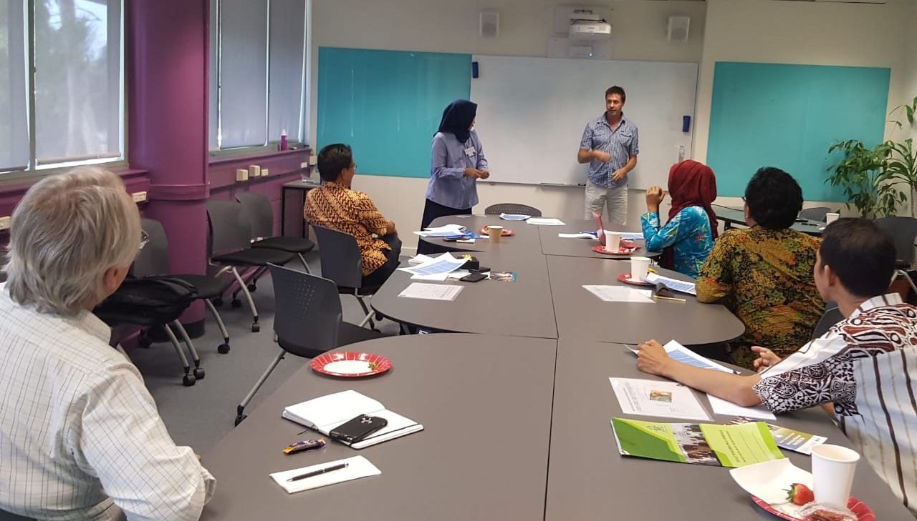
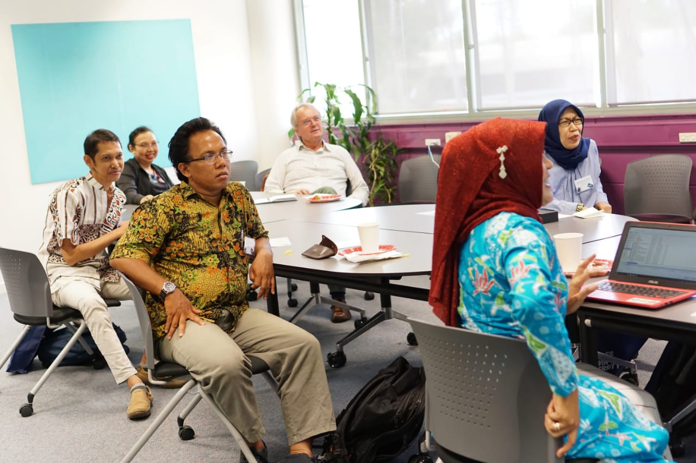
Figure 1 (Bold). Title of the image (Times New Roman, Font 12, Centered, Single-spaced)
(Source of image – Times New Roman, Font 10, Centered, Single-spaced)

The caption for the table should be above the table.

Table 1 (Bold). Title of the table (Times New Roman, Font 12, Centered, Single-spaced)
No. | Indication | Frequency | Percentage (%)
1. | Very positive | 19 | 47.5%
2. | Positive | 15 | 37.5%
3. | Neutral | 4 | 10%
4. | Negative | 1 | 2.5%
5. | Very Negative | 1 | 2.5%
Total |  | 40 | 100%
(Source of table – Times New Roman, Font 10, Right-aligned, Single-spaced)
(e.g. Adopted from Thorne, 2012)

The caption for the chart should be above the chart.

Chart 1 (Bold). Title of the chart (Times New Roman, Font 12, Centered, Single-spaced)
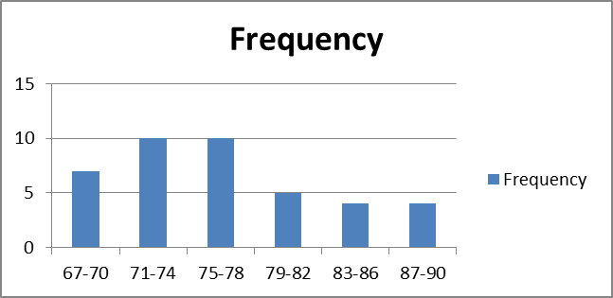

DISCUSSION (1000-1500 words)
Present a logical analysis of the study findings. Provide evidence to support your analysis by citing the work of previous studies or existing theories. [Explain whether your findings agree or disagree with previous studies and why].

CONCLUSION (500-1000 words)
Clearly state how the objectives of the study are accomplished.

LIMITATIONS AND STUDY FORWARD
No study covers all aspects of the research problem. Therefore, the author needs to discuss the limitations or gaps of this study. A plan or future scope of the study should also be provided.

ACKNOWLEDGEMENT
Indicate the funding source or help received in carrying out your study and/or preparing the manuscript, if any, before the references. To avoid ghostwriting, we suggest all co-authors clearly mention their contribution to the article.

REFERENCES
(Use Reference Manager (Mendeley is highly suggested), APA Style 7th Edition.)
(Times New Roman, Font 12, Left-aligned, Single-spaced, Add Space Before Paragraph)

Examples

Book – Single Author
Broughton, G. (2003). Teaching English as a foreign language. Routledge.
Book – Many Authors
Cohen, L., Manion, L., & Morrison, K. (2005). Research methods in education. Routledge.
Book – Edited Book, No Author
Leitch, M. G., & Rushton, C. J. (Eds.). (2019). A new companion to Malory. D. S. Brewer.
Book – Edited Book with an Author/Authors
Malory, T. (2017). Le morte darthur (P. J. C. Field, Ed.). D. S. Brewer.
Book – Later Edition
Goldstein, E. B. (2010). Sensation and perception (8th ed.). Wadsworth Cengage Learning.

Article or Chapter in an Edited Book
Armstrong, D. (2019). Malory and character. In M. G. Leitch & C. J. Rushton (Eds.), A new companion to Malory (pp. 144-163). D. S. Brewer.
Online Books
Brown, J. D. (2009). Research ethics in New Zealand: A student guide. https://doi.org/10.1000/182
Maclean, H. (1932). Nursing in New Zealand: History and reminiscences. http://www.nzetc.org/tm/scholarly/tei-MacNurs.html
Journal Article
Muniandy, J. (2012). Teaching and learning constructive listening skills: A study among EFL learners. Journal of Social Sciences and Humanities, 7(1), 149-160.
Journal Article with DOI
Sultana, M., & Zaki, S. (2015). Proposing Project Based Learning as an alternative to traditional ELT pedagogy at public colleges in Pakistan. International Journal for Lesson and Learning Studies, 4(2), 155–173. https://doi.org/10.1108/IJLLS-09-2013-0049
Conference & Symposium Proceedings
Published Paper in A Book
Bowker, N., & Tuffin, K. (2002). Users with disabilities’ social and economic development through online access. In M. Boumedine (Ed.), Proceedings of the IASTED International Conference on Information and Knowledge Sharing (pp. 122–127). ACTA Press.
Unpublished Paper
Chan, N. N., Walker-Gleaves, A., & Remedios, R. (2013, June 16-19). Ubiquitous learning: The lived experience of students learning with smartphones [Session #2: Innovative online learning environments]. Sixth Conference of MIT’s Learning International Networks Consortium (LINC), Cambridge, Massachusetts.
Unpublished Thesis or Dissertation
Bowker, N. I. (2003). What it means to be online for people with disabilities [Unpublished doctoral dissertation]. Massey University.

Published Thesis or Dissertation
Angeli, E. L. (2012). Networks of communication in emergency medical services (Publication No. 3544643) [Doctoral dissertation, Purdue University]. ProQuest Dissertations Publishing.
Online Thesis or Dissertation
Mason, R. L. (2011). Learning at work: A model of learning & development for younger workers [Doctoral dissertation, Massey University]. Semantic Scholar. http://mro.massey.ac.nz/handle/10179/2862
Webpage
Price, D. (2018, March 23). Laziness does not exist. Medium. https://humanparts.medium.com/laziness-does-not-exist-3af27e312d01
American Society for the Prevention of Cruelty to Animals. (2019, November 21). Justice served: Case closed for over 40 dogfighting victims. https://www.aspca.org/news/justice-served-case-closed-over-40-dogfighting-victims
Magazine Article
Jianying, H. (2007, July). Qing tomb enigmas. China Today, 56(7), 72–76.
Online Magazine Article
The domino effect. (2008, July 3). The Economist. http://www.economist.com/​node/​11667810?story_id=11667810
Newspaper Article
Howe, J. (2007, November 16). Manawatu worth $8.1b. Manawatu Standard, p. 1.
Online Newspaper Article
Government urged to act on child poverty. (2008, August 7). New Zealand Herald. http://www.nzherald.co.nz/​section/​1/​story.cfm?​c_id=1&​objectid=10525782
Group Author (Corporations, Government Agencies, Organizations, etc.)
Merriam-Webster. (2008). Braggadocio. In Merriam-Webster’s Advanced Learner’s English Dictionary. Merriam-Webster.
Bureau of International Organization Affairs. (2018). U.S. contributions to international organizations, 2017 [Annual report]. U.S. Department of State. https://www.state.gov/u-s-contributions-to-international-organizations/

Entry in a Dictionary, Thesaurus, or Encyclopedia with a Group Author
Merriam-Webster, Incorporated. (1997). Goat. In Merriam Webster’s collegiate dictionary (10th ed., pp. 499-500). Merriam-Webster, Incorporated.

Report by a Government Agency or Other Organization
United States Government Accountability Office. (2019). Performance and accountability report: Fiscal year 2019. https://www.gao.gov/assets/710/702715.pdf

